***PROJECT ON SWIGGY***

*Slide 1:*

**program:**

package gui2;

import java.awt.EventQueue;

import javax.swing.JFrame;

import java.awt.Toolkit;

import javax.swing.JButton;

import java.awt.BorderLayout;

import javax.swing.ImageIcon;

import java.awt.event.ActionListener;

import java.awt.event.ActionEvent;

import javax.swing.AbstractButton;

import javax.swing.JOptionPane;

import javax.swing.JTextField;

import javax.swing.JPasswordField;

import java.awt.Color;

import java.awt.Font;

public class gui4 {

private JFrame frame;

private JTextField txtWelcomeToSwiggy_1;

private JTextField txtUsername;

private JTextField txtPassword;

private JTextField txtSindhu;

private JPasswordField passwordField;

private JButton btnSignup;

private JPasswordField passwordField_1;

/**

* Launch the application.

*/

public static void main(String[] args) {

EventQueue.invokeLater(new Runnable() {

public void run() {

try {

gui4 window = new gui4();

window.frame.setVisible(true);

} catch (Exception e) {

e.printStackTrace();

}

}

});

}

/**

* Create the application.

*/

public gui4() {

initialize();

}

/**

* Initialize the contents of the frame.

*/

private void initialize() {

frame = new JFrame();

frame.getContentPane().setLayout(null);

txtWelcomeToSwiggy_1 = new JTextField();

txtWelcomeToSwiggy_1.setFont(new Font("Lucida Handwriting", Font.BOLD | Font.ITALIC, 11));

txtWelcomeToSwiggy_1.setForeground(Color.RED);

txtWelcomeToSwiggy_1.setText("WELCOME TO SWIGGY");

txtWelcomeToSwiggy_1.setBounds(528, 95, 179, 20);

frame.getContentPane().add(txtWelcomeToSwiggy_1);

txtWelcomeToSwiggy_1.setColumns(10);

txtUsername = new JTextField();

txtUsername.setFont(new Font("Tahoma", Font.BOLD | Font.ITALIC, 11));

txtUsername.setForeground(Color.BLUE);

txtUsername.setText("USERNAME:");

txtUsername.setBounds(514, 147, 86, 20);

frame.getContentPane().add(txtUsername);

txtUsername.setColumns(10);

txtPassword = new JTextField();

txtPassword.setFont(new Font("Tahoma", Font.BOLD | Font.ITALIC, 11));

txtPassword.setForeground(Color.BLUE);

txtPassword.setText("PASSWORD:");

txtPassword.setBounds(514, 191, 86, 20);

frame.getContentPane().add(txtPassword);

txtPassword.setColumns(10);

txtSindhu = new JTextField();

txtSindhu.setText("sindhu");

txtSindhu.setBounds(635, 147, 86, 20);

frame.getContentPane().add(txtSindhu);

txtSindhu.setColumns(10);

btnSignup = new JButton("SIGNUP");

btnSignup.addActionListener(new ActionListener() {

public void actionPerformed(ActionEvent e) {

if(txtSindhu.getText().equals("sindhu"))

{

JOptionPane.showMessageDialog(frame,"welcome,start swiggying "+txtSindhu.getText());

}

else

{

JOptionPane.showMessageDialog(frame,"sorry invalid user");

} }

});

btnSignup.setFont(new Font("Tahoma", Font.BOLD | Font.ITALIC, 11));

btnSignup.setForeground(Color.BLUE);

btnSignup.setBounds(528, 261, 200, 50);

frame.getContentPane().add(btnSignup);

passwordField = new JPasswordField();

passwordField.setBounds(635, 191, 86, 20);

frame.getContentPane().add(passwordField);

passwordField_1 = new JPasswordField();

passwordField_1.setBounds(675, 191, 6, 20);

frame.getContentPane().add(passwordField_1);

JButton button = new JButton("");

button.setIcon(new ImageIcon("X:\\pics\\2.png"));

button.setBounds(10, 0, 867, 503);

frame.getContentPane().add(button);

}

**Output:**

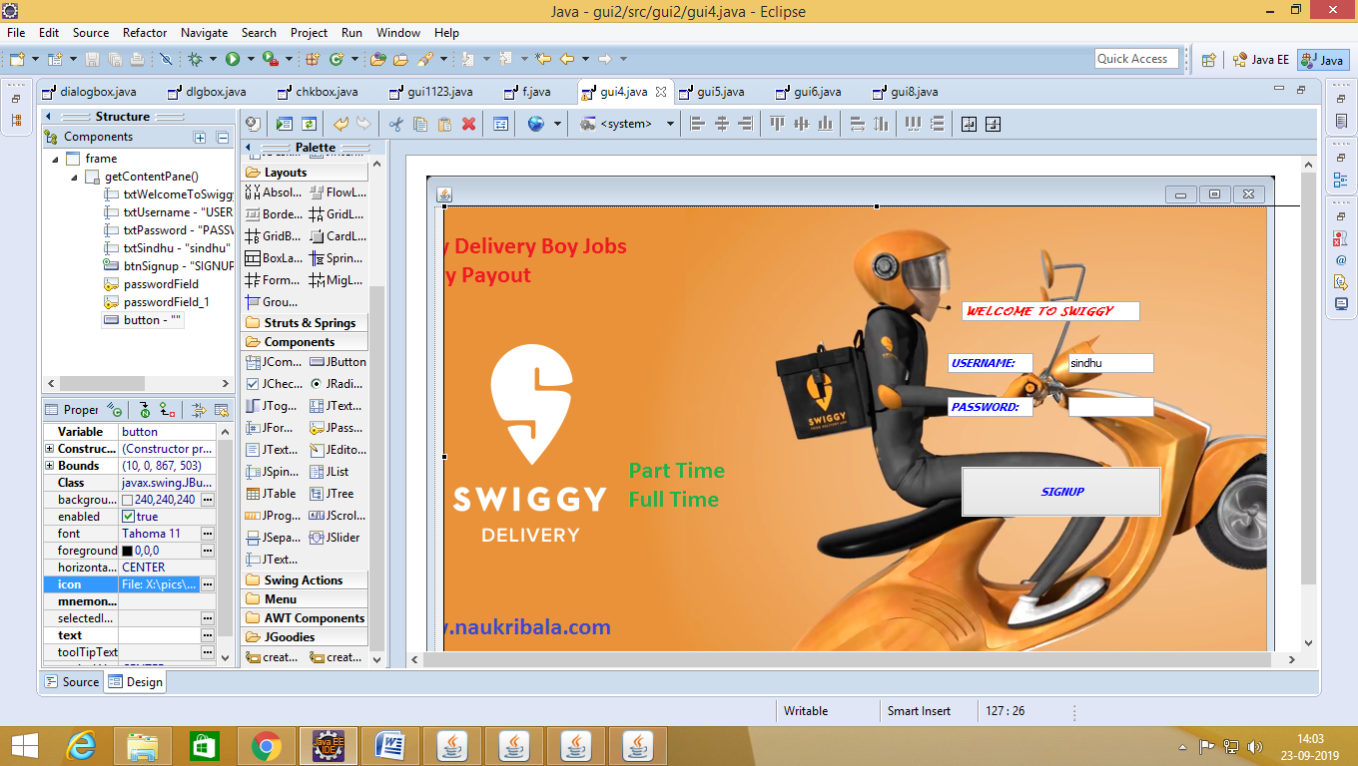

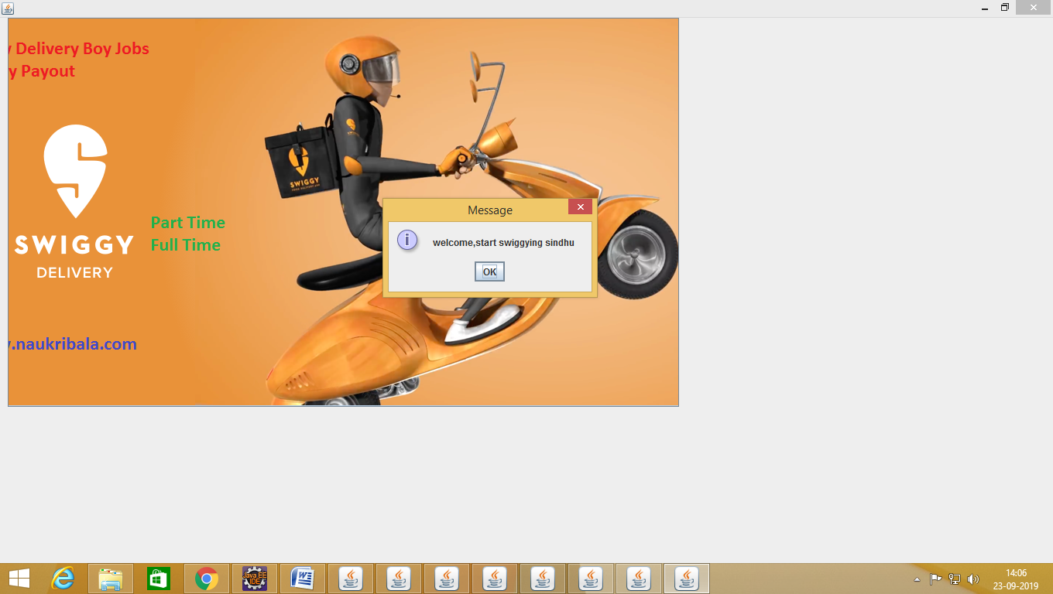

***Slide 2:***

**Program:**

package gui2;

import java.awt.EventQueue;

import javax.swing.JFrame;

import javax.swing.JOptionPane;

import javax.swing.JTextField;

import javax.swing.JTextPane;

import java.awt.Font;

import java.awt.Color;

import javax.swing.JCheckBox;

import javax.swing.JButton;

import javax.swing.ImageIcon;

import java.awt.event.ActionListener;

import java.awt.event.ActionEvent;

public class gui6 {

private JFrame frame;

private JTextField txtVeg;

private JTextField txtNonveg;

/**

* Launch the application.

*/

public static void main(String[] args) {

EventQueue.invokeLater(new Runnable() {

public void run() {

try {

gui6 window = new gui6();

window.frame.setVisible(true);

} catch (Exception e) {

e.printStackTrace();

}

}

});

}

/**

* Create the application.

*/

public gui6() {

initialize();

}

/**

* Initialize the contents of the frame.

*/

private void initialize() {

frame = new JFrame();

frame.getContentPane().setFont(new Font("Elephant", Font.BOLD | Font.ITALIC, 26));

frame.getContentPane().setForeground(new Color(0, 128, 0));

frame.setBounds(100, 100, 935, 592);

frame.setDefaultCloseOperation(JFrame.EXIT_ON_CLOSE);

frame.getContentPane().setLayout(null);

txtVeg = new JTextField();

txtVeg.setForeground(new Color(255, 20, 147));

txtVeg.setFont(new Font("Lucida Calligraphy", Font.BOLD | Font.ITALIC, 20));

txtVeg.setText("VEG\r\n");

txtVeg.setBounds(143, 36, 124, 50);

frame.getContentPane().add(txtVeg);

txtVeg.setColumns(10);

txtNonveg = new JTextField();

txtNonveg.setForeground(new Color(255, 20, 147));

txtNonveg.setFont(new Font("Lucida Calligraphy", Font.BOLD | Font.ITALIC, 20));

txtNonveg.setText("NON-VEG");

txtNonveg.setBounds(429, 36, 200, 50);

frame.getContentPane().add(txtNonveg);

txtNonveg.setColumns(10);

JTextPane textPane = new JTextPane();

textPane.setBounds(532, 76, -46, 20);

frame.getContentPane().add(textPane);

JCheckBox chckbxNoodles = new JCheckBox("Noodles");

chckbxNoodles.setFont(new Font("Sitka Text", Font.ITALIC, 15));

chckbxNoodles.setForeground(new Color(0, 0, 255));

chckbxNoodles.setBounds(143, 106, 124, 23);

frame.getContentPane().add(chckbxNoodles);

JCheckBox chckbxManchuriya = new JCheckBox("manchuriya");

chckbxManchuriya.setFont(new Font("Sitka Text", Font.ITALIC, 15));

chckbxManchuriya.setForeground(new Color(0, 0, 255));

chckbxManchuriya.setBounds(143, 132, 124, 23);

frame.getContentPane().add(chckbxManchuriya);

JCheckBox chckbxBiryani= new JCheckBox("Biryani\r\n");

chckbxBiryani.setFont(new Font("Sitka Text", Font.ITALIC, 15));

chckbxBiryani.setForeground(new Color(0, 0, 255));

chckbxBiryani.setBounds(143, 158, 124, 23);

frame.getContentPane().add(chckbxBiryani);

JCheckBox chckbxfriedrice = new JCheckBox("fried rice");

chckbxfriedrice.setFont(new Font("Sitka Text", Font.ITALIC, 15));

chckbxfriedrice.setForeground(new Color(0, 0, 255));

chckbxfriedrice.setBounds(143, 184, 124, 23);

frame.getContentPane().add(chckbxfriedrice);

JCheckBox chckbxChickenLollipop = new JCheckBox("chicken lollipop");

chckbxChickenLollipop.setFont(new Font("Segoe UI Semilight", Font.BOLD | Font.ITALIC, 16));

chckbxChickenLollipop.setForeground(new Color(128, 0, 0));

chckbxChickenLollipop.setBounds(452, 103, 151, 23);

frame.getContentPane().add(chckbxChickenLollipop);

JCheckBox chckbxMuttonBiryani = new JCheckBox("mutton biryani");

chckbxMuttonBiryani.setFont(new Font("Segoe UI Semilight", Font.BOLD | Font.ITALIC, 16));

chckbxMuttonBiryani.setForeground(new Color(128, 0, 0));

chckbxMuttonBiryani.setBounds(452, 132, 151, 23);

frame.getContentPane().add(chckbxMuttonBiryani);

JCheckBox chckbxPronsBiryani = new JCheckBox("Prawns biryani");

chckbxPronsBiryani.setFont(new Font("Segoe UI Semilight", Font.BOLD | Font.ITALIC, 16));

chckbxPronsBiryani.setForeground(new Color(128, 0, 0));

chckbxPronsBiryani.setBounds(452, 155, 151, 23);

frame.getContentPane().add(chckbxPronsBiryani);

JCheckBox chckbxFishCurry = new JCheckBox("fish curry");

chckbxFishCurry.setFont(new Font("Segoe UI Semilight", Font.BOLD | Font.ITALIC, 16));

chckbxFishCurry.setForeground(new Color(128, 0, 0));

chckbxFishCurry.setBounds(452, 181, 151, 23);

frame.getContentPane().add(chckbxFishCurry);

JButton btnOrderNow = new JButton("ORDER NOW");

btnOrderNow.setFont(new Font("Tahoma", Font.BOLD | Font.ITALIC, 25));

btnOrderNow.addActionListener(new ActionListener() {

public void actionPerformed(ActionEvent e) {

if(chckbxNoodles.isSelected())

{

JOptionPane.showMessageDialog(chckbxNoodles,"you have selected Noodles");

}

if(chckbxManchuriya.isSelected())

{

JOptionPane.showMessageDialog(chckbxManchuriya,"you have selected Manchuriya ");

}

if(chckbxBiryani.isSelected())

{

JOptionPane.showMessageDialog(chckbxBiryani,"you have selected Biryani ");

}

if(chckbxfriedrice.isSelected())

{

JOptionPane.showMessageDialog(chckbxfriedrice,"you have selected friedrice ");

}

if(chckbxChickenLollipop.isSelected())

{

JOptionPane.showMessageDialog(chckbxChickenLollipop,"you have selected ChickenLollipop ");

}

if(chckbxMuttonBiryani.isSelected())

{

JOptionPane.showMessageDialog(chckbxMuttonBiryani,"you have selected MuttonBiryani ");

}

if(chckbxPronsBiryani.isSelected())

{

JOptionPane.showMessageDialog(chckbxPronsBiryani,"you have selected PronsBiryani ");

}

if(chckbxFishCurry.isSelected())

{

JOptionPane.showMessageDialog(chckbxFishCurry,"you have selected FishCurry ");

}

}

});

btnOrderNow.setForeground(Color.GREEN);

btnOrderNow.setBackground(Color.RED);

btnOrderNow.setBounds(269, 240, 250, 72);

frame.getContentPane().add(btnOrderNow);

JButton button = new JButton("");

button.setIcon(new ImageIcon("X:\\pics\\swiggy-free-food-200rs.jpg"));

button.setBounds(0, 11, 944, 531);

frame.getContentPane().add(button);

}

}

**OUTPUT:**

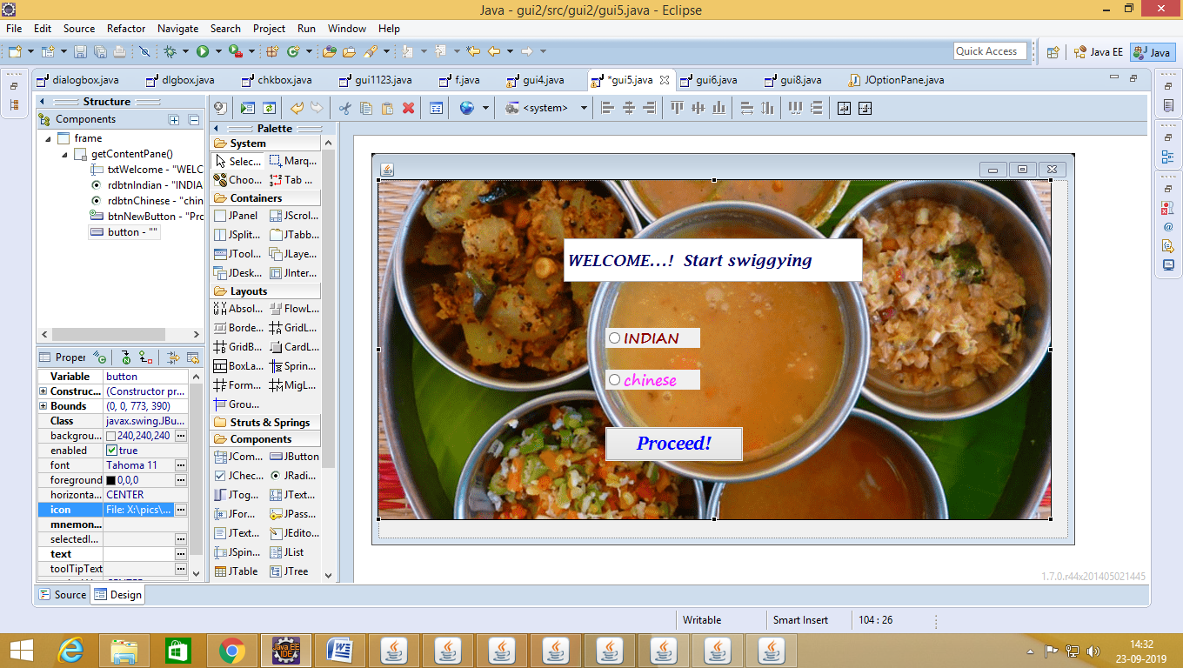

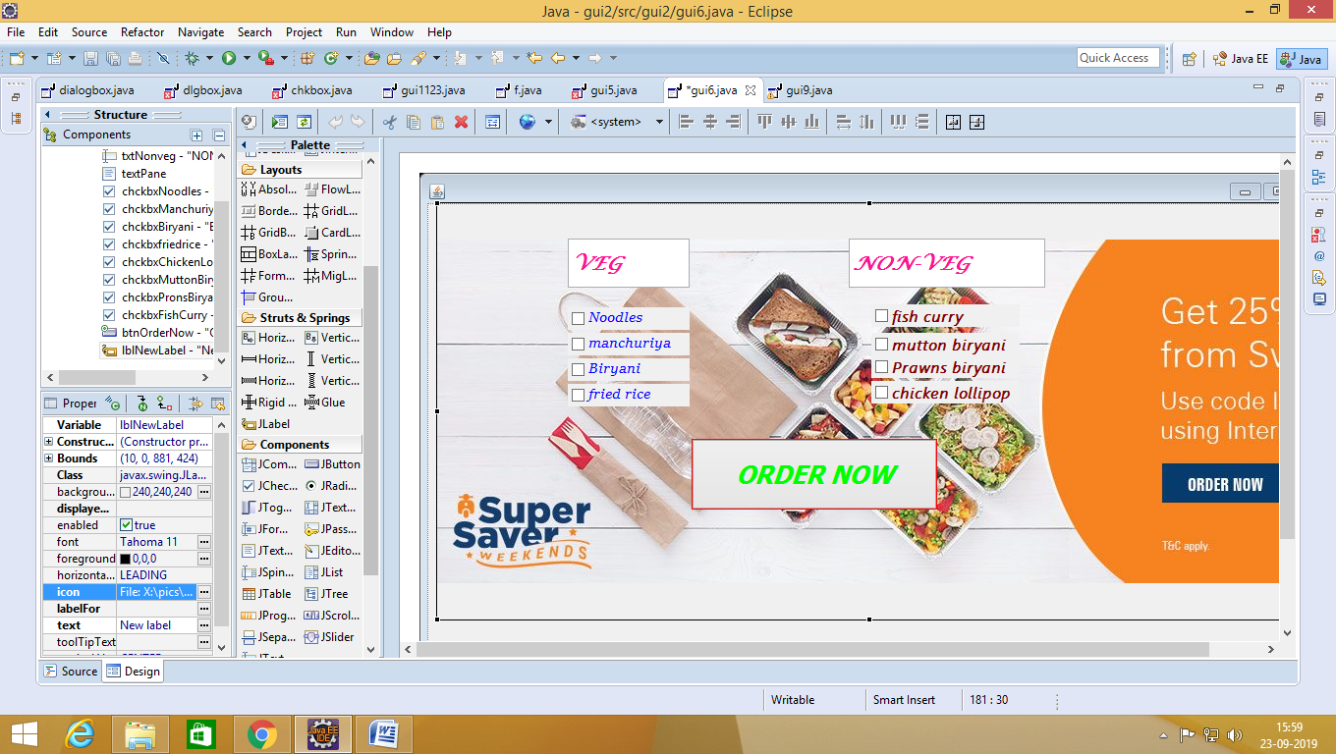

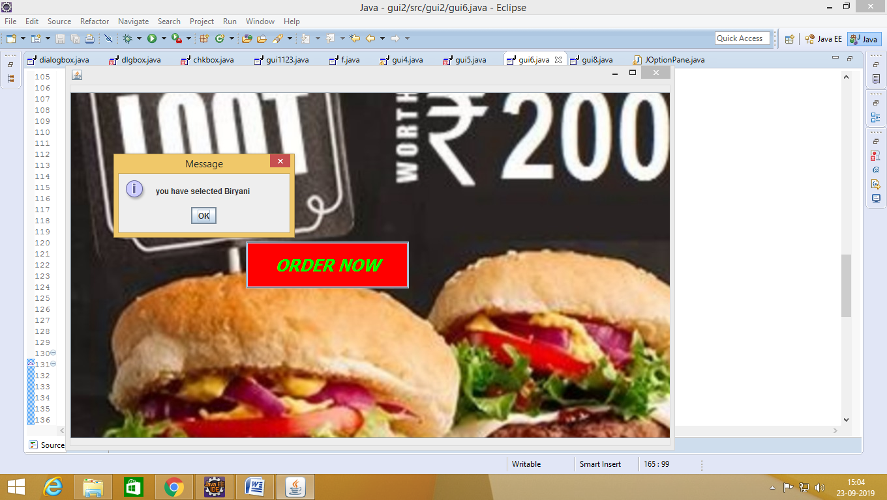

s

***Slide 3:***

**PROGRAM:**

**package gui2;**

**import java.awt.EventQueue;**

**import javax.swing.JFrame;**

**import javax.swing.JLabel;**

**import javax.swing.JOptionPane;**

**import javax.swing.JRadioButton;**

**import javax.swing.JButton;**

**import java.awt.Color;**

**import java.awt.Font;**

**import javax.swing.ImageIcon;**

**import java.awt.event.ActionListener;**

**import java.awt.event.ActionEvent;**

**public class gui9 {**

**private JFrame frame;**

**/\*\***

**\* @wbp.nonvisual location=171,359**

**\*/**

**private final JLabel label = new JLabel("New label");**

**private JRadioButton rdbtnCashOnDelivery;**

**private JRadioButton rdbtnGooglePay;**

**private JRadioButton rdbtnPaytm;**

**private JButton btnPay;**

**private JButton btnExit;**

**private JLabel label_1;**

**/\*\***

**\* Launch the application.**

**\*/**

**public static void main(String[] args) {**

**EventQueue.invokeLater(new Runnable() {**

**public void run() {**

**try {**

**gui9 window = new gui9();**

**window.frame.setVisible(true);**

**} catch (Exception e) {**

**e.printStackTrace();**

**}**

**}**

**});**

**}**

**/\*\***

**\* Create the application.**

**\*/**

**public gui9() {**

**initialize();**

**}**

**/\*\***

**\* Initialize the contents of the frame.**

**\*/**

**private void initialize() {**

**frame = new JFrame();**

**frame.setBounds(100, 100, 884, 375);**

**frame.setDefaultCloseOperation(JFrame.EXIT_ON_CLOSE);**

**frame.getContentPane().setLayout(null);**

**JLabel lblPayment = new JLabel("PAYMENT");**

**lblPayment.setFont(new Font("Verdana", Font.BOLD | Font.ITALIC, 26));**

**lblPayment.setForeground(new Color(0, 0, 0));**

**lblPayment.setBounds(557, 25, 200, 50);**

**frame.getContentPane().add(lblPayment);**

**rdbtnCashOnDelivery = new JRadioButton("CASH ON DELIVERY");**

**rdbtnCashOnDelivery.setFont(new Font("Sitka Text", Font.BOLD | Font.ITALIC, 17));**

**rdbtnCashOnDelivery.setForeground(new Color(128, 0, 128));**

**rdbtnCashOnDelivery.setBounds(566, 86, 168, 23);**

**frame.getContentPane().add(rdbtnCashOnDelivery);**

**rdbtnGooglePay = new JRadioButton("GOOGLE PAY");**

**rdbtnGooglePay.setFont(new Font("Sitka Text", Font.BOLD | Font.ITALIC, 17));**

**rdbtnGooglePay.setForeground(new Color(128, 0, 128));**

**rdbtnGooglePay.setBounds(566, 125, 168, 23);**

**frame.getContentPane().add(rdbtnGooglePay);**

**rdbtnPaytm = new JRadioButton("PAYTM");**

**rdbtnPaytm.setFont(new Font("Sitka Text", Font.BOLD | Font.ITALIC, 17));**

**rdbtnPaytm.setForeground(new Color(128, 0, 128));**

**rdbtnPaytm.setBounds(566, 163, 164, 23);**

**frame.getContentPane().add(rdbtnPaytm);**

**btnPay = new JButton("PAY");**

**btnPay.addActionListener(new ActionListener() {**

**public void actionPerformed(ActionEvent e) {**

**if(rdbtnCashOnDelivery.isSelected())**

**{**

**JOptionPane.showMessageDialog(rdbtnCashOnDelivery,"pay CashOnDelivery");**

**}**

**if(rdbtnGooglePay.isSelected())**

**{**

**JOptionPane.showMessageDialog(rdbtnCashOnDelivery,"pay on GooglePay");**

**}**

**if(rdbtnPaytm.isSelected())**

**{JOptionPane.showMessageDialog(rdbtnCashOnDelivery,"pay on Paytm");**

**});**

**btnPay.setFont(new Font("Vrinda", Font.BOLD, 28));**

**btnPay.setForeground(new Color(0, 0, 255));**

**btnPay.setBounds(422, 231, 168, 23);**

**frame.getContentPane().add(btnPay);**

**btnExit = new JButton("EXIT");**

**btnExit.addActionListener(new ActionListener() {**

**public void actionPerformed(ActionEvent e) {**

**if(btnExit.isSelected())**

**{**

**JOptionPane.showMessageDialog(btnExit,"THANK YOU");**

**}**

**}**

**});**

**btnExit.setFont(new Font("Vrinda", Font.BOLD, 28));**

**btnExit.setForeground(new Color(0, 0, 255));**

**btnExit.setBounds(623, 231, 107, 23);**

**frame.getContentPane().add(btnExit);**

**label_1 = new JLabel("");**

**label_1.setIcon(new ImageIcon("X:\\pics\\swiggy-weekend-offer-D.jpg"));**

**label_1.setBounds(-458, 11, 1373, 325);**

**frame.getContentPane().add(label_1);**

**}**

**}**

**OUTPUT:**

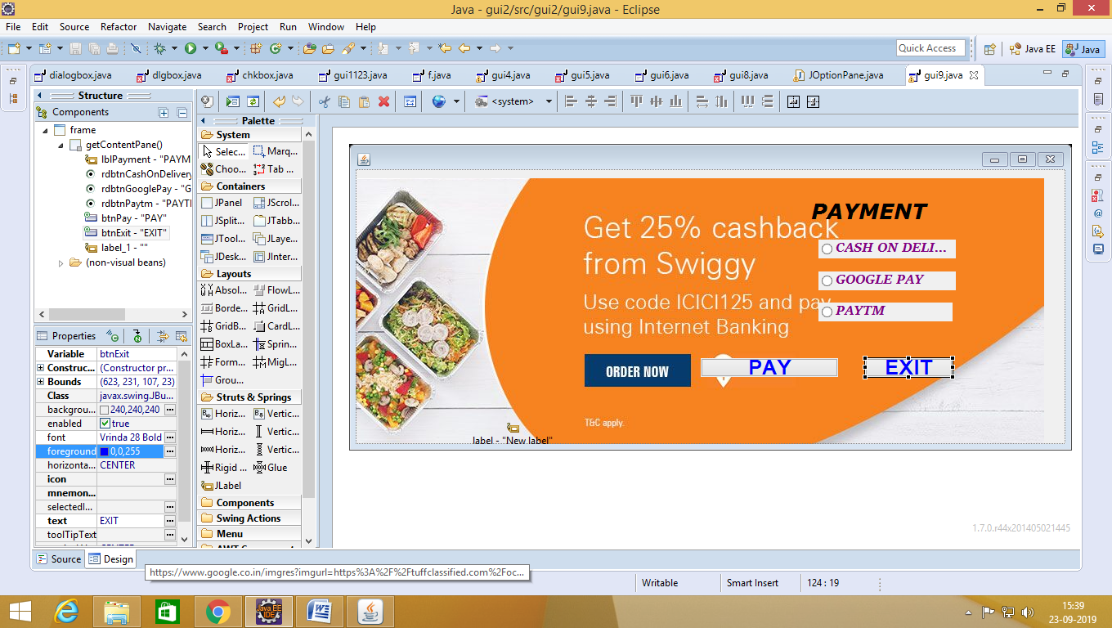

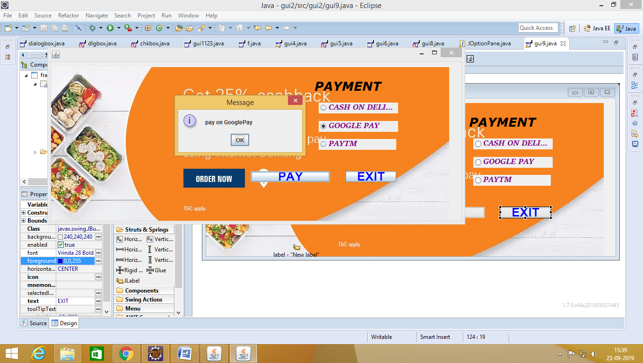

***COMING SOON.....***

***Your order is on the way!!!***

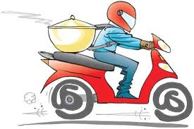

**THANK YOU!**